Nepal Engineering College
Center for Advanced
Assessment-2009

Time: 3hrs Sem: Spring
Program: Civil FM: 100
Course Engineering Math-III PM: 50

Candidates are requested to give their answers in their own words as far as practicable.
Figures in the margin indicate full marks.
Attempt ALL questions.
1. a) Show that
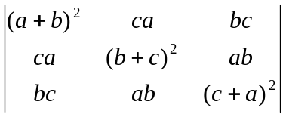=2abc(a+b+c) 7
(b) Solve
x+y+z=6
x-y+z=2
2x-y+3z=9
by Gauss-elimination method 8
2 (a) Check the consistency of the system of equations
x+y+z=3
x+2y+3z=4
x+4y+9z=6 8
&solve it.
(b) Define subspace of a vector space and if
V=R be a vector space if
W={ (x,y): x+2y=0}
is W a subspace of V?
3 (a) Define eigen value and eigen vector.
Find eigen value & eigen vector of
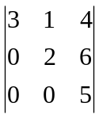 8
(b) Find the interval ,center and radius of convergence of the series
x-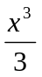+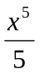-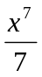+….. 8
4 (a) Expand secx in Maclaurin series and hence the secx tanx . 7
(b) State and prove P-test 8
5 (a) Find the discretional derivative of
f=4xz-3x²yz² at (2,1,-2) along Z-axis. 7
(b) Check the exactness of the integral
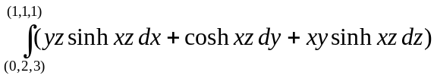 8
6 (a) Evaluate 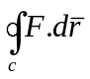By using Green's theorem if
(x² e^{y} , y²e^{x}), where c is the rectangle with vertices (0,0),(2,0), (2,3), (0,3). 7
(b) Find 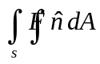 by using Gauss divergence theorem if F= (x³,y³,z³) ,S is the sphere x²+y²+z²=9 8
7 Attempt all the questions 2x5
(a) Check the linear dependent or independent of the vectors (1,0,0),(1,1,0,),(1,1,1)
(b) If T:R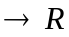 be defined by T(x)=x+4, is T a linear transformation
(c) Test the convergence or divergent of the series
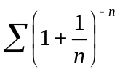
(d) If f=x³+y³+3xyz then find grad(f).
(e) If =2y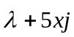 find curl of v.

